Copyright for test papers and marking guides remains with West Australian Test Papers.
Test papers may only be reproduced within the purchasing school according to the advertised Conditions of Sale.
Test papers should be withdrawn after use and stored securely in the school until 15th October 2020.



SEMESTER TWO

MATHEMATICS
SPECIALIST
UNITS 3 & 4

2020

SOLUTIONS

Calculator−Free Solutions

1. $u=\sec\left(θ\right) → \frac{du}{dθ}=\frac{-\sin{θ}}{- \cos^{2}{θ}} → du=\sec{θ}\tan{θ}dθ$
$u\left(θ\right)=\frac{1}{\cos{θ}} → u\left(0\right)=1 and u\left(\frac{π}{3}\right)=\frac{1}{0.5}=2$
$$∴\int_{0}^{\frac{π}{3}}{\sec{θ}\tan{θ}dθ}=\int_{1}^{2}{du}={\left[u\right]}_{1}^{2}=2-1=1 [4]$$

2. $P\left(z\right)$ has real coefficients ⇒ $\overline{z}=2-i$ is also a solution.
$∴\left(z-2-i\right)\left(z-2+i\right)=z^{2}-4z+5$ is a factor of $P\left(z\right)$

 | $$z^{2}$$ | $$-2z$$ | $$5$$
$$z^{2}-4z+5$$ | $$z^{4}$$ | $$-6z^{3}$$ | $$18z^{2}$$ | $$-30z$$ | $$25$$
 | $$z^{4}$$ | $$-4z^{3}$$ | $$5z^{2}$$
 | $$0$$ | $$-2z^{3}$$ | $${13xz}^{2}$$ | $$-30z$$ | $$25$$
 |  | $$-2z^{3}$$ | $$8z^{2}$$ | $$-10z$$
 |  | $$0$$ | $$5z^{2}$$ | $$-20z$$ | $$25$$
 |  |  | $$5z^{2}$$ | $$-20z$$ | $$25$$
 |  |  | $$0$$ | $$0$$ | $$0$$

$∴z^{2}-2z+5=0$
$z=\frac{2±\sqrt{4-20}}{2}=1±2i$
Solutions are $z=1±2i, 2±i$ [5]

3. $\frac{2x^{2}+1}{x\left(x^{2}+1\right)}=\frac{Ax+B}{x^{2}+1}+\frac{C}{x} → 2x^{2}+1=x\left(Ax+B\right)+C\left(x^{2}+1\right)$
$x=0 → 1=0+C → C=1$
$x=1 → 3=A+B+2$
$x=-1 → 3=A-B+2$
$∴A=1, B=0$
$$∴\int_{1}^{2}{\frac{2x^{2}+1}{x^{3}+x}dx}=\int_{1}^{2}{\left(\frac{x}{x^{2}+1}+\frac{1}{x}\right)dx}={\left[\frac{1}{2}\ln\left(x^{2}+1\right)+\ln\left|x\right|\right]}_{1}^{2}$$

$=\frac{1}{2}\ln\left(5\right)+\ln\left(2\right)-\frac{1}{2}\ln\left(2\right)=\frac{1}{2}\ln{10}=\ln{\sqrt{10}}$ as required [5]

4. (a) $f\left(g\left(x\right)\right)=f\left(-\left|x\right|\right)={\left|x\right|}^{2}-2\left|x\right|-3=x^{2}-2\left|x\right|-3$
For $x≥0, f\left(g\left(x\right)\right)=x^{2}-2x-3={\left(x-1\right)}^{2}+4$
which has a turning point at $\left(1, -4\right)$
$∴D_{x}=R$ and $R_{y}=\left\{y∈R:y≥-4\right\}$

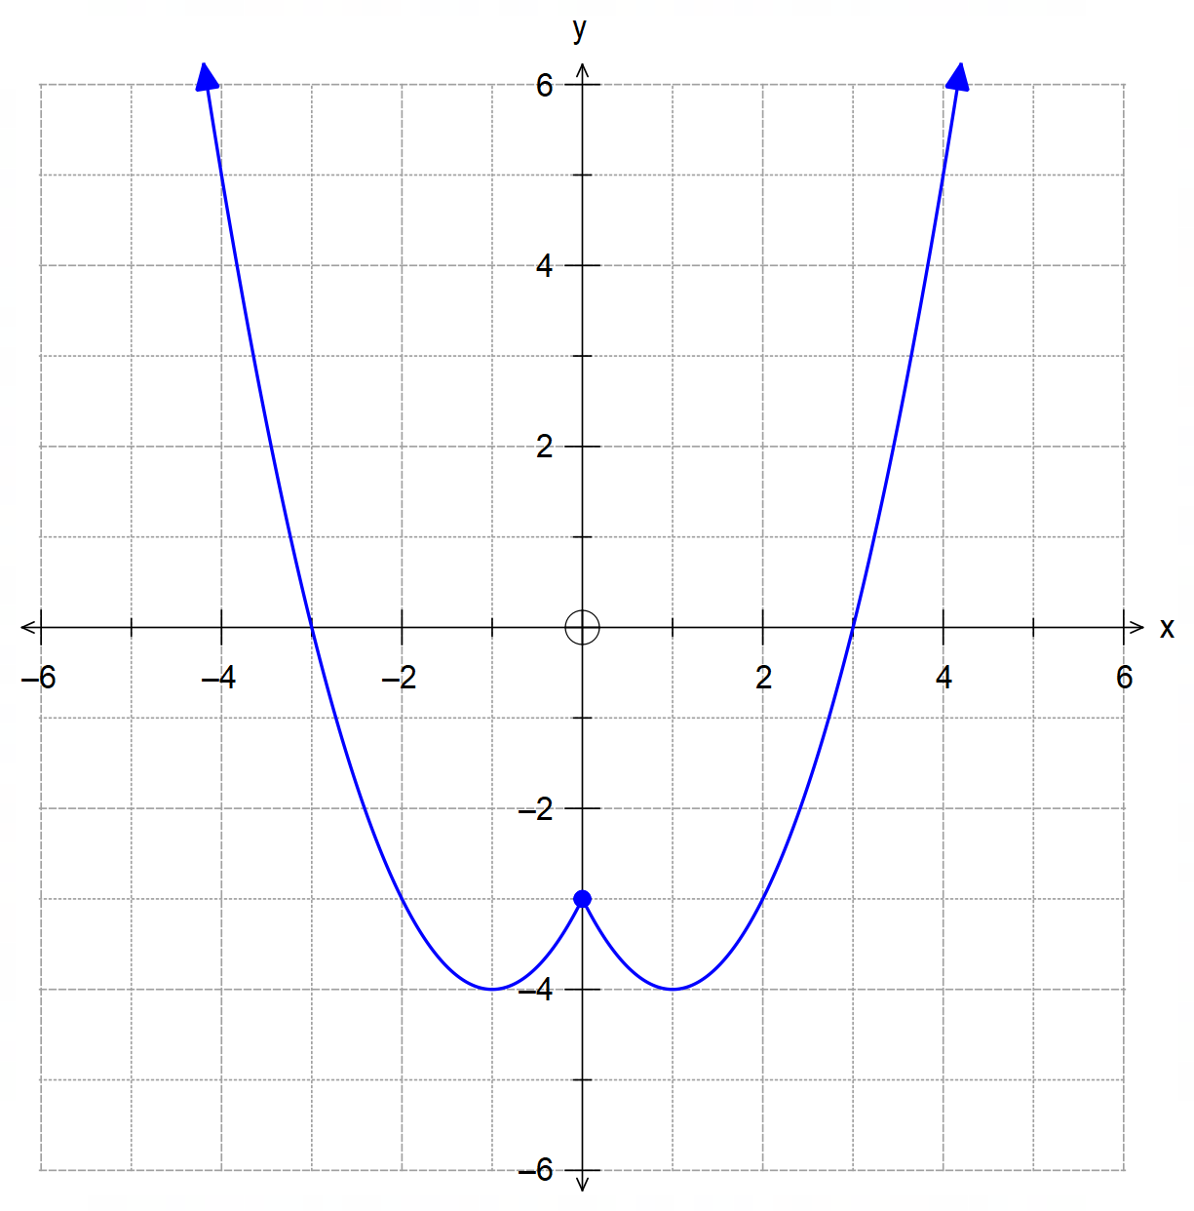 (b)

Parabolic shape

Mirror image over the y-axis

Local min at $\left(±1, -4\right)$, and roots at $x=±3$

(c) $f\left(x\right)$ has its turning point at $\left(-1, -4\right)$, $∴k=-1$
$∴f^{-1}\left(x\right)=\sqrt{x+4}-1$

(d) (i) $g\left(f^{-1}\left(0\right)\right)=g\left(1\right)=-\left|1\right|=-1$

(ii) $g\left(f^{-1}\left(f\left(x+1\right)\right)\right)=g\left(x+1\right)=-\left|x+1\right|$ [10]

5. (a) R is a solid sphere centred at $\left(1, 1, 0\right)$ with radius 3 units.
${\left|r\right|}_{max}=\left|\begin{matrix}1 \\ 1 \\ 0\end{matrix}\right|+3=\sqrt{2}+3$ units

(b) xz plane $→y=0,$ therefore the intersection is given by
${\left(x-1\right)}^{2}+{\left(0-1\right)}^{2}+{\left(z\right)}^{2}=9$
${\left(x-1\right)}^{2}+z^{2}=8$
$∴$ circle centred at $\left(1, 0, 0\right)$ and radius $2\sqrt{2}$ units.

5. (c) The line is given by $r=\left(\begin{matrix}5+λ \\ 2 \\ -λ\end{matrix}\right)$, hence:
$\left|\left(\begin{matrix}5+λ \\ 2 \\ -λ\end{matrix}\right)-\left(\begin{matrix}1 \\ 1 \\ 0\end{matrix}\right)\right|=3$
$∴{\left(4+λ\right)}^{2}+1^{2}+{\left(-λ\right)}^{2}=3^{2}$
$2λ^{2}+8λ+8=0$
$2{\left(λ+2\right)}^{2}=0 → ∴λ=-2$
Unique solution implies the line is tangent to the sphere R
$r\left(-2\right)=\left(\begin{matrix}5-2 \\ 2 \\ -2\end{matrix}\right)=\left(\begin{matrix}3 \\ 2 \\ 2\end{matrix}\right)$
Point of tangency is $\left(3, 2, 2\right)$. [9]

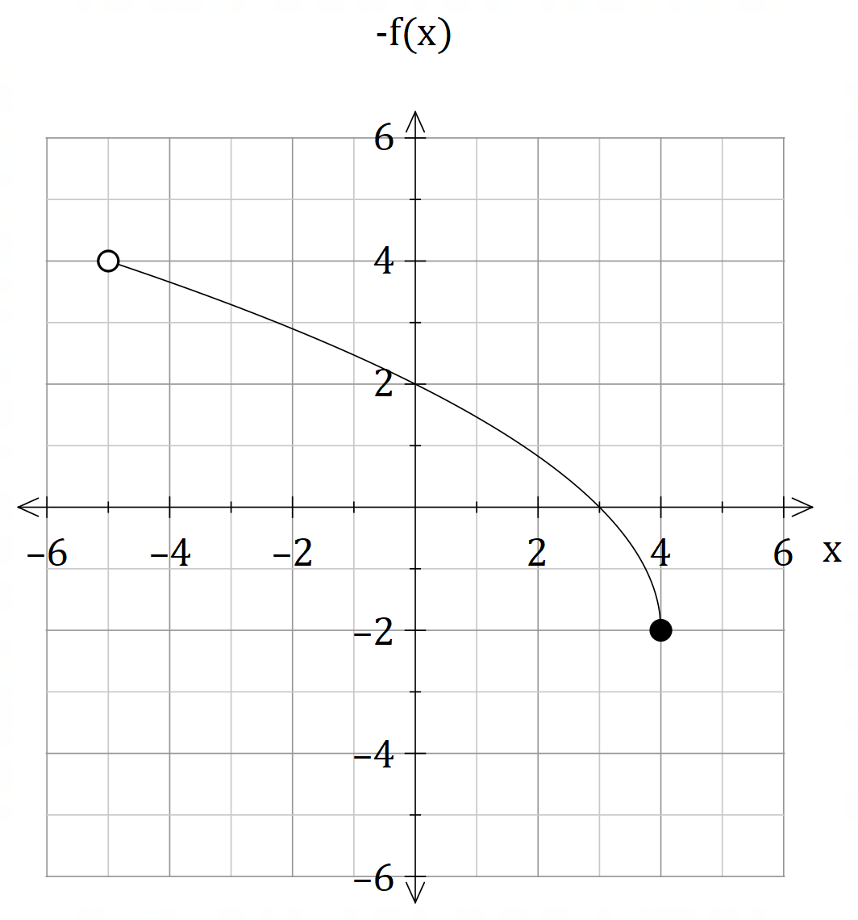6. (a)

Square root function with correct orientation, root at $x=3$ and y-intercept at
$$y=2$$

Open boundary at $x=-5$ closed boundary at $x=4$

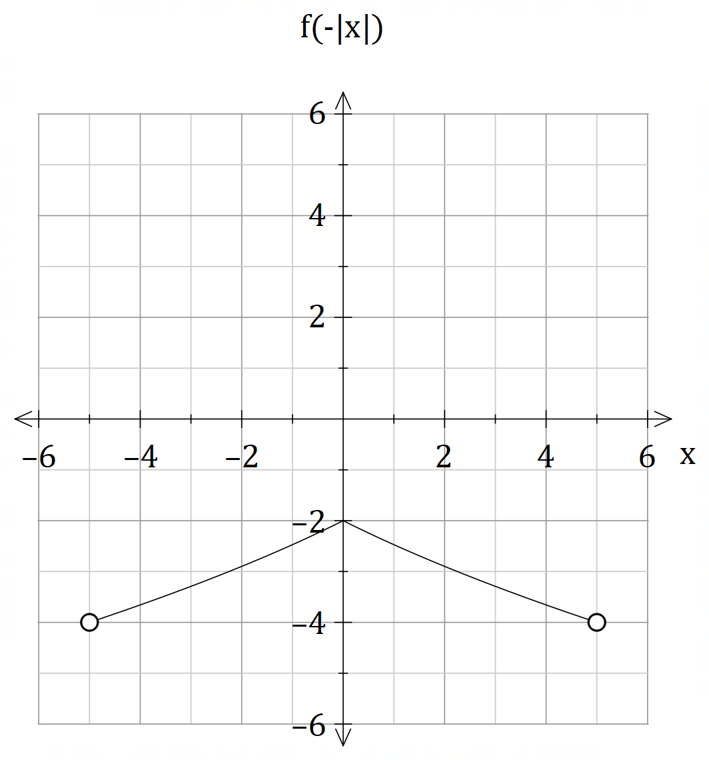

Mirror image over the
y-axis, completely below the x-axis

y-intercept at $y=-2$,
open boundaries at $±5$.

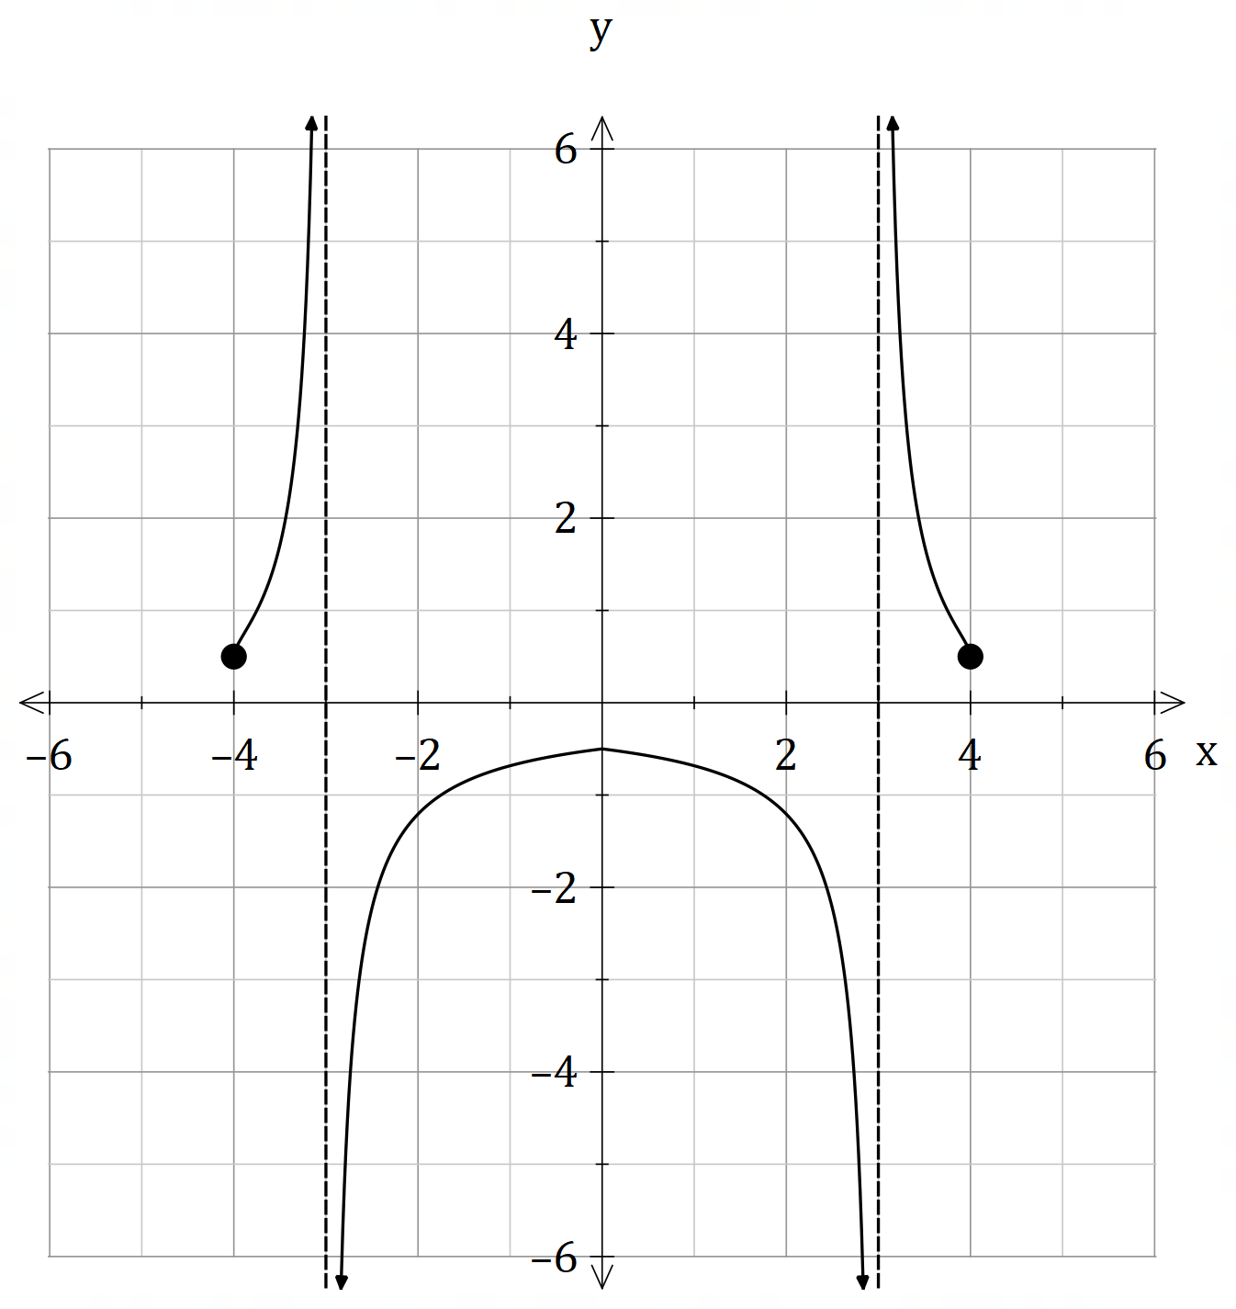6. (b)

Poles at $x=±3$

Closed boundaries at $x=±4$
Y-intercept at $y=-0.5$

Behaviour on either side of both poles

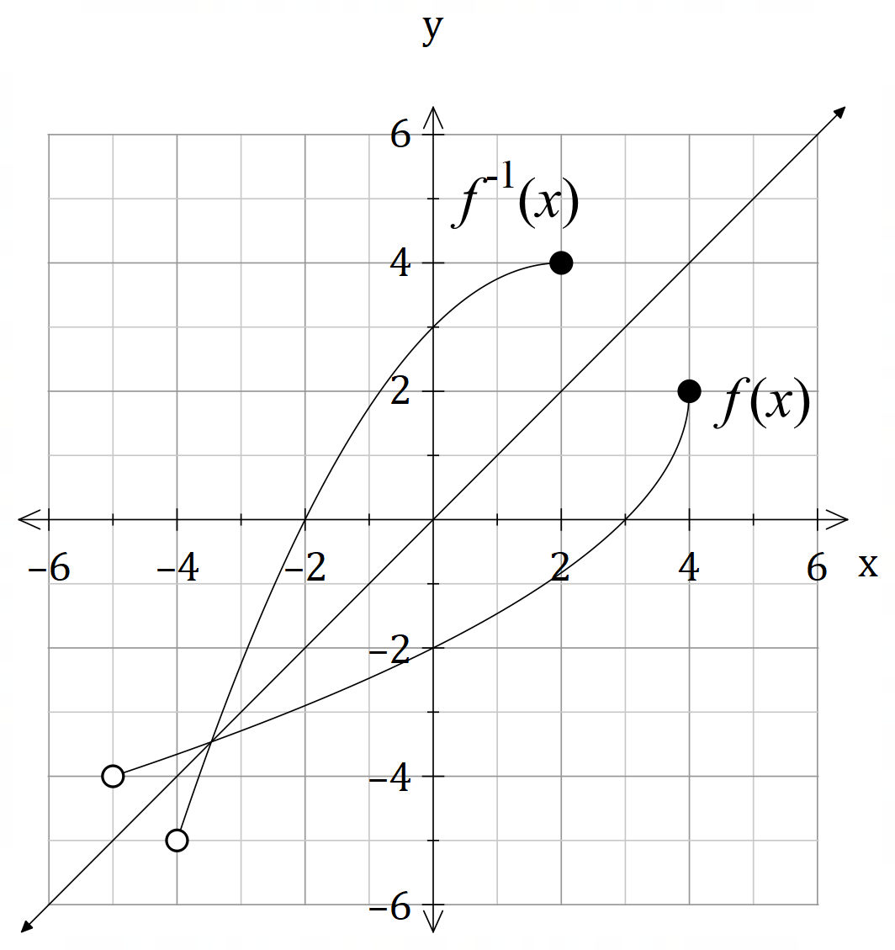 (c) $f\left(x\right)$ and $f^{-1}\left(x\right)$ are shown below, hence, for $f^{-1}\left(x\right)$:

$$D_{x}=\left\{x∈R:-4<x≤2\right\}$$

$$R_{y}=\left\{y∈R: -5<y≤4\right\}$$

[9]

7. (a) (i) The internal parabolic outline is given by $y=\frac{x^{2}}{4}-4$
$∴x^{2}=4\left(y+4\right)$
Hence, the volume is given by:
$$v_{y}=π\int_{0}^{21}{x^{2}dy}=π\int_{0}^{21}{4\left(y+4\right)dy}=4π\int_{0}^{21}{\left(y+4\right)dy }$$
$∴f\left(y\right)=y+4$ as required

7. (a) (ii)
$$V_{y}=4π\int_{0}^{21}{\left(y+4\right)dy}=4π{\left[\frac{y^{2}}{2}+4y\right]}_{0}^{21}$$
$∴V_{y}=4π{\left[y\left(\frac{y}{2}+4\right)\right]}_{0}^{21}=4π×21×\left(\frac{21}{2}+4\right)$
$=2π×21×29=1218π$ cm³

(b) V = V_{curved side} + V_{base}
= (V_{outter shell} – V_{inner shell} ) + V_{base}
$$∴V=π\int_{0}^{21}{5\left(y+5\right)dy}- π\int_{0}^{21}{4\left(y+4\right)dy}+π\int_{-1}^{0}{5\left(y+5\right)dy}$$
[7]

8. (a) $a=\frac{dv}{dt}×\frac{dx}{dx}$
$=\frac{dx}{dt}×\frac{dv}{dx}=v\frac{dv}{dx}$ as required

(b) $\frac{d}{dx}→ 4x^{2}-v^{2}=1$
$8x-2v\frac{dv}{dx}=0$
$∴v\frac{dv}{dx}=a=4x$ [4]

Calculator−assumed Solutions

9. (a)
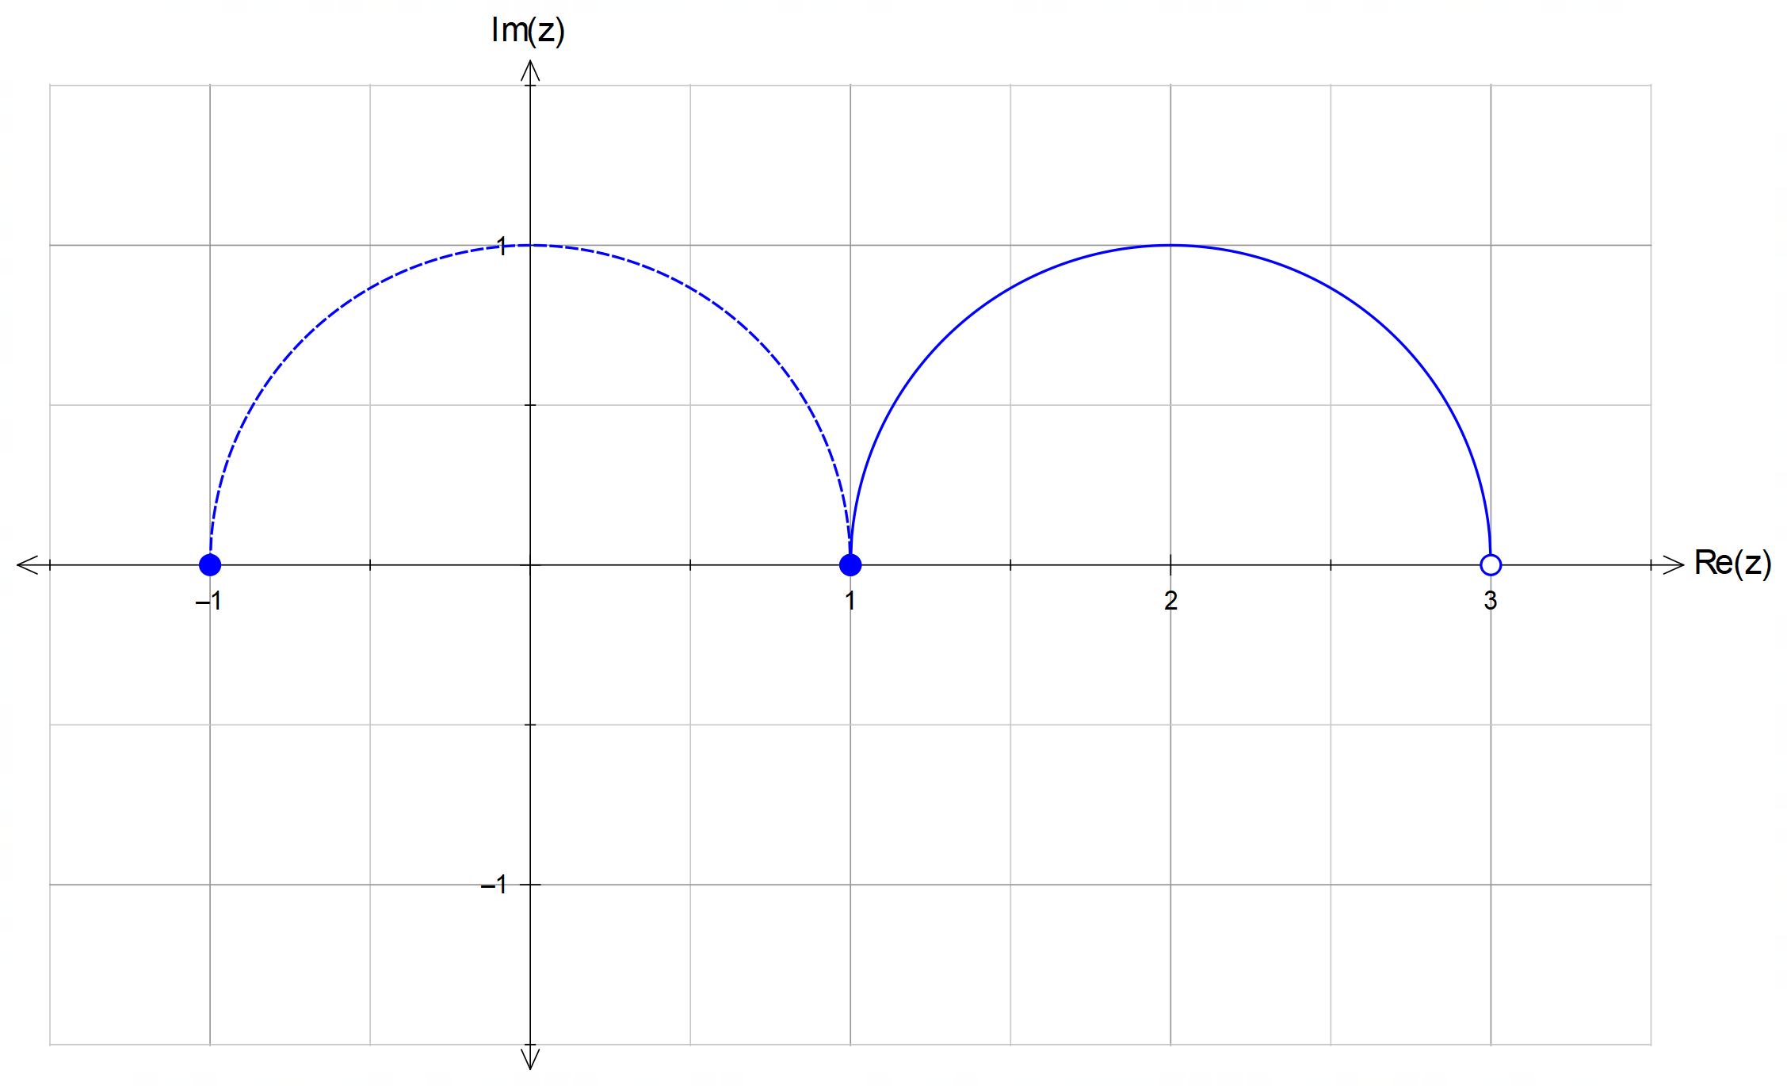

Semicircle

Centred at (2,0) and radius 1

Discontinuous at $x=3$
(or $x=-1$ for FT marks if drawn on LHS)

(b)
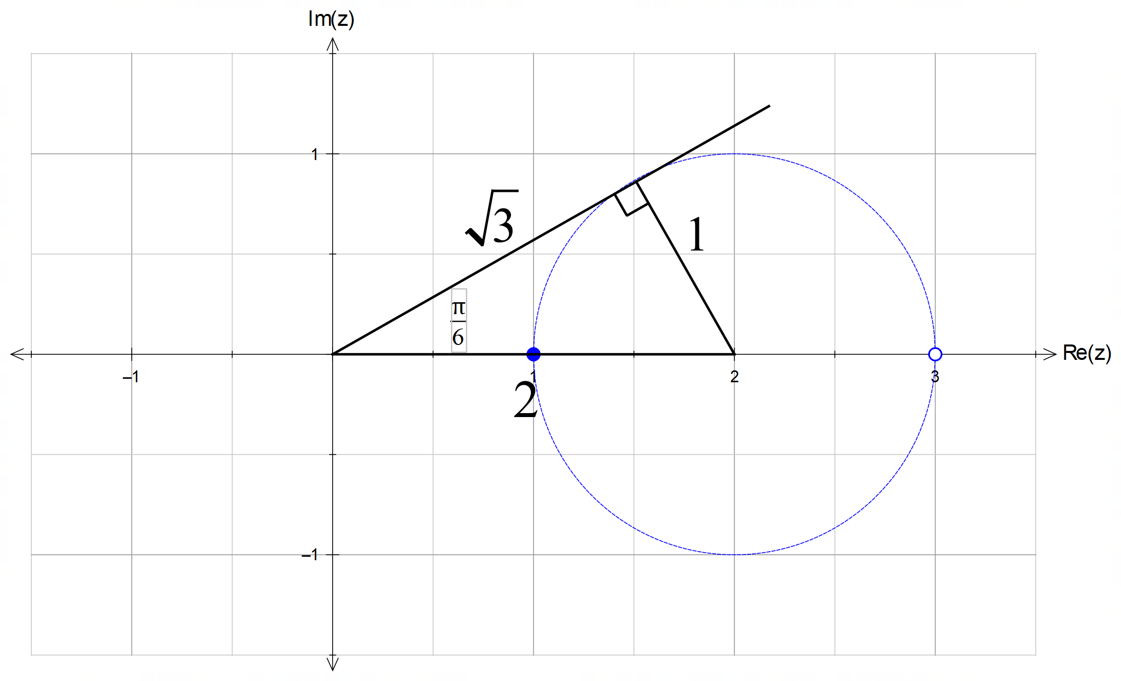

From diagram, ${\arg\left(z-2\right)}_{max}=\frac{π}{6}$ and $\left|z-2\right|=\sqrt{3}$

OR

${\arg\left(z-2\right)}_{max}=π$ and $\left|z-2\right|=\sqrt{3}$ for follow through marks
if the circle is drawn on the LHS of the y-axis. [5]

10. (a) ${\left.\frac{dy}{dx}\right|}_{\left(\frac{π}{2}, 2\right)}=2×\sin{\frac{π}{2}}=2$

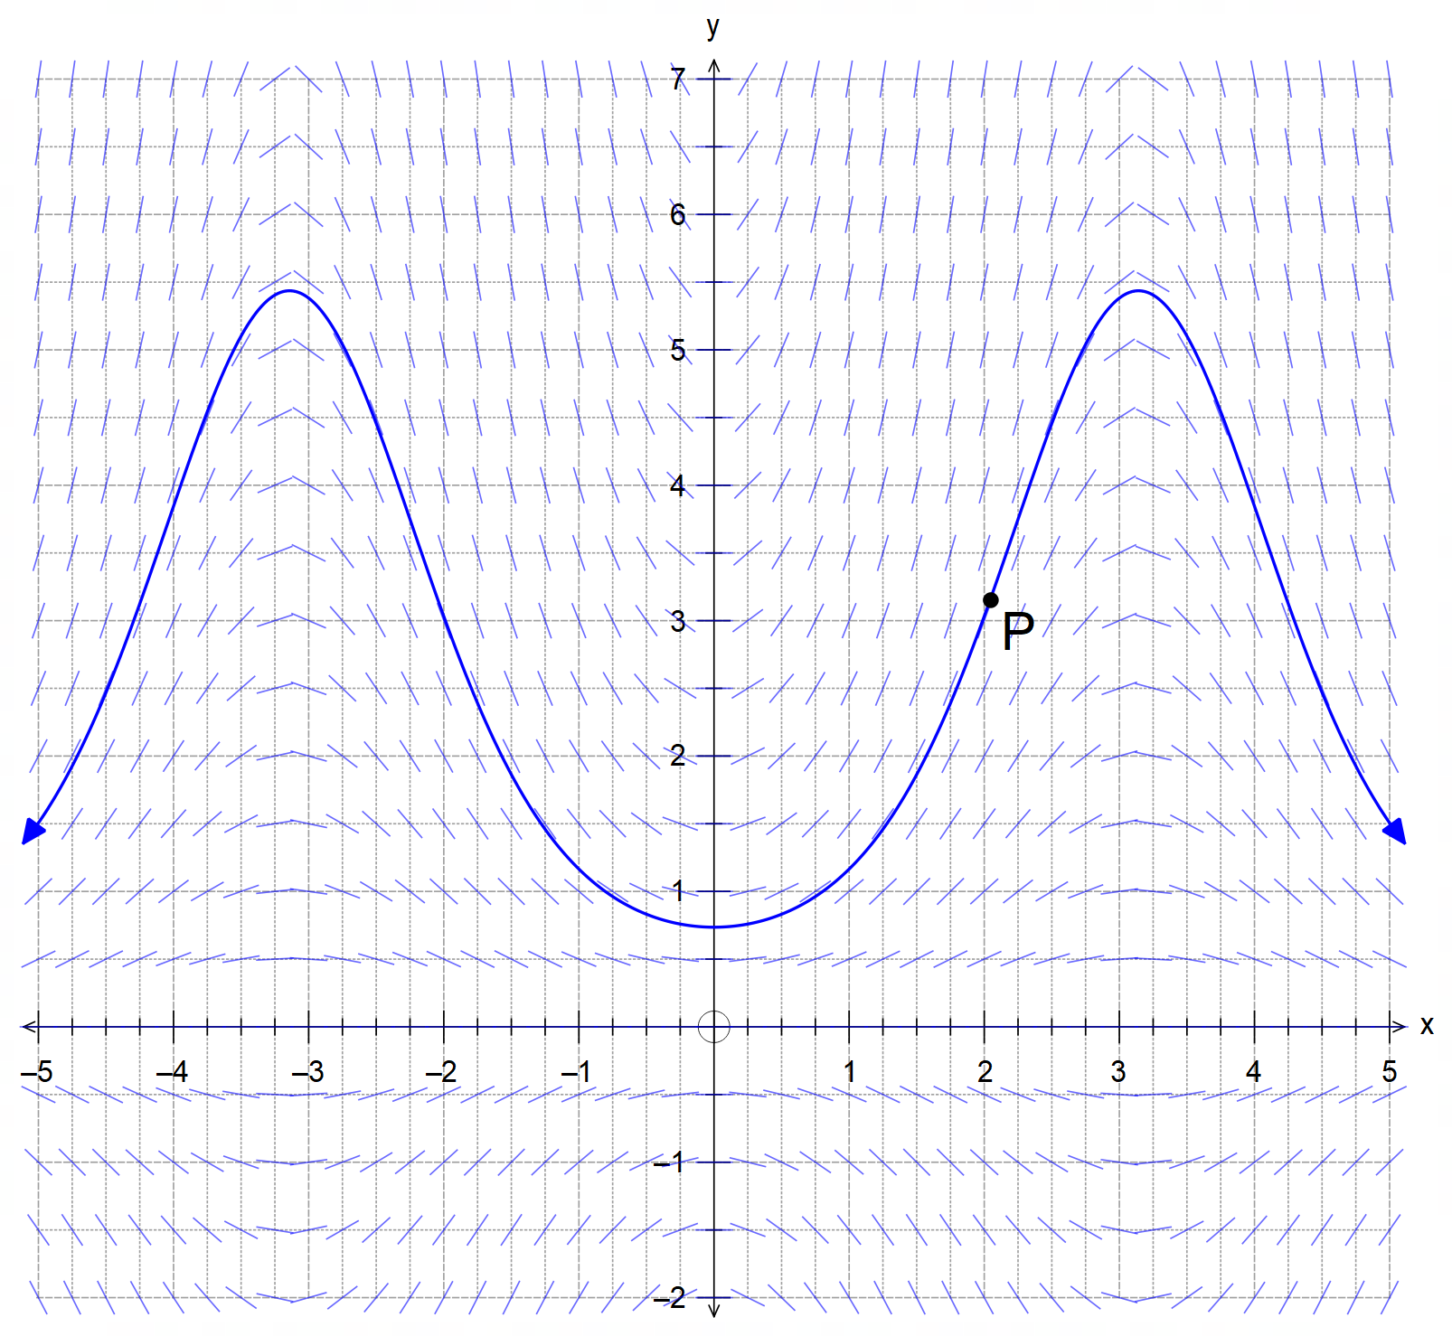
(b)

Follows the isoclines to show a cyclic curve
(must be wider along the y-axis, it cannot look like a sinusoid)

Passes through the point P

(c) $\frac{dy}{dx}=y\sin{x} → \frac{dy}{y}=\sin{x}dx$
$$∴\int{\frac{1}{y}dy}=\int{\sin{x}dx}$$
$∴\ln\left|y\right|=-\cos{x}+C_{1}$
$y=e^{-\cos{x}+C_{1}}=e^{C_{1}}×e^{-\cos{x}}=C_{2}e^{-\cos{x}}$
$\left(\frac{π}{2},2\right) → 2=C_{2}×e^{0} → C_{2}=2$
$∴y=2e^{-\cos{x}}$ [7]

11. (a) (i) $z^{4}=-1=\operatorname{cis}\left(π+2kπ\right), k=0, ±1, -2$
$∴z=\operatorname{cis}\left(\frac{π+2kπ}{4}\right), k=0,±1, -2$
$∴z=\operatorname{cis}\left(\frac{π}{4}\right),\operatorname{cis}\left(\frac{3π}{4}\right),\operatorname{cis}\left(-\frac{π}{4}\right),\operatorname{cis}\left(-\frac{3π}{4}\right)$

11. (a) (ii) Solutions from (a)(i) move two units up:
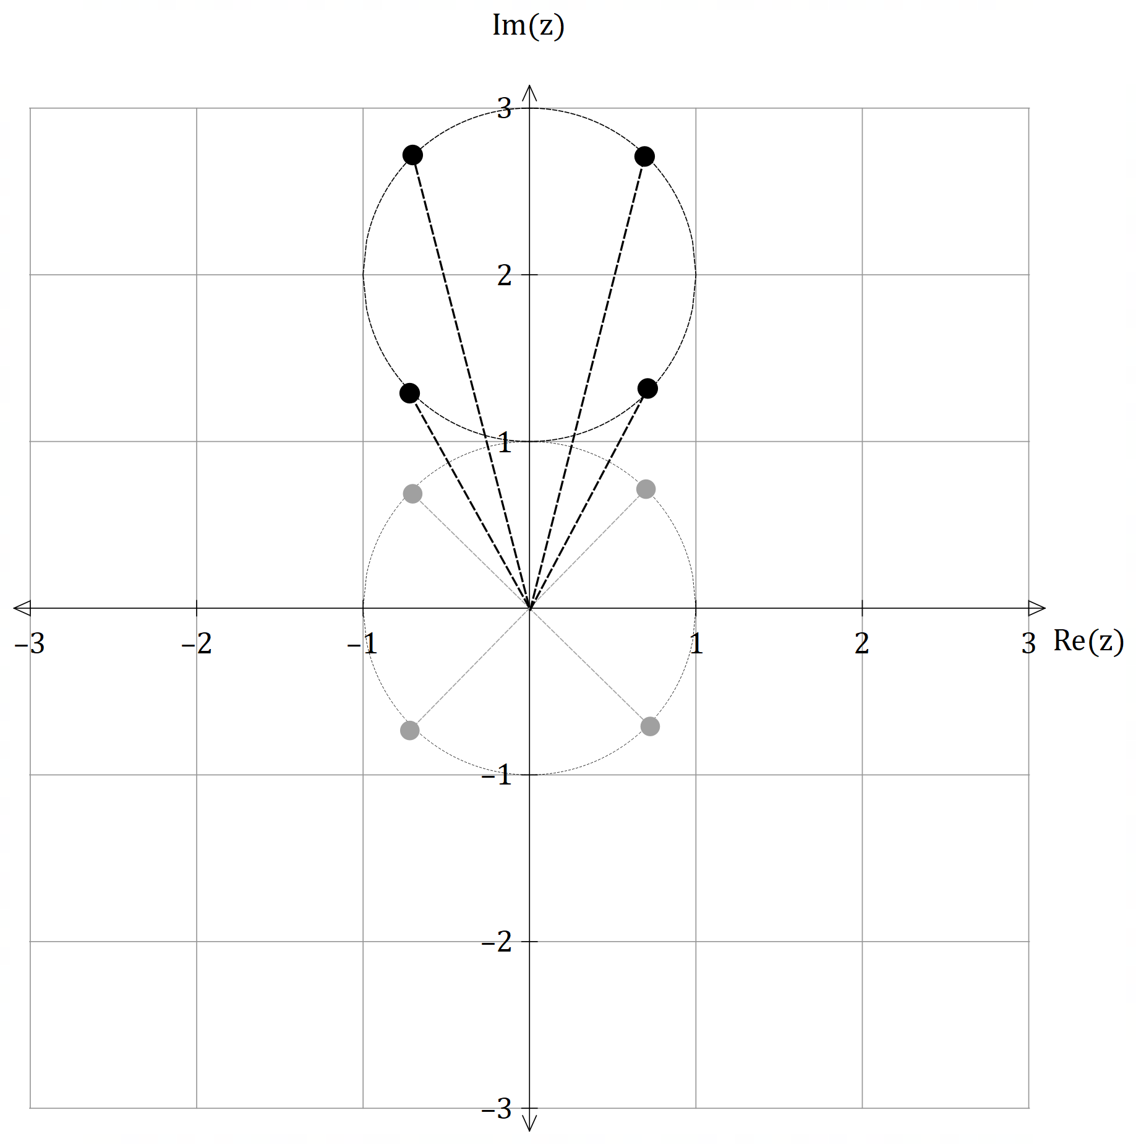

4 solutions equidistant from 2i

equally spaced at $\frac{π}{2}$ radians from each other within the circle centred at $2i$

(b) (i) $z=\frac{\sqrt{3}+i}{1-i}×\frac{1+i}{1+i}=\left(\frac{\sqrt{3}-1}{2}\right)+\left(\frac{\sqrt{3}+1}{2}\right)i$
$∴Re\left(z\right)=\frac{\sqrt{3}-1}{2} and Im\left(z\right)=\frac{\sqrt{3}+1}{2}$
(or CAS)

(ii) $z=\frac{\sqrt{3}+i}{1-i}=\frac{2\operatorname{cis}\left(\frac{π}{6}\right)}{\sqrt{2}\operatorname{cis}\left(-\frac{π}{4}\right)}=\frac{2}{\sqrt{2}}\operatorname{cis}\left(\frac{π}{6}+\frac{π}{4}\right)=\sqrt{2}\operatorname{cis}\left(\frac{5π}{12}\right)$
$∴\sqrt{2}\cos\left(\frac{5π}{12}\right)=Re\left(z\right)=\frac{\sqrt{3}-1}{2}$
$\cos\left(\frac{5π}{12}\right)=\frac{\sqrt{3}-1}{2\sqrt{2}}=\frac{\sqrt{2}}{4}\left(\sqrt{3}-1\right)$ as required [13]

12. (a) $r\left(t\right)=\int{v\left(t\right)dt}=\left(\int{2t dt}\right)i+\left(\int{\sin{t}dt}\right)j$
$=\left(t^{2}+C_{1}\right)i+\left(-\cos{t}+C_{2}\right)j$
$r\left(0\right)=\left(\begin{matrix}C_{1} \\ -1+C_{2}\end{matrix}\right)=\left(\begin{matrix}2 \\ 1\end{matrix}\right) → \begin{matrix}C_{1}=2 \\ C_{2}=2\end{matrix}$
$∴r\left(t\right)=\left(t^{2}+2\right)i+\left(2-\cos{t}\right)j$

(b) $a\left(t\right)=\frac{d}{dt}v\left(t\right)=2i+\cos{t}j$
$∴a\left(0\right)=2i+\cos{0}j=2i+j$
$∴\left|a\left(0\right)\right|=\left|\begin{matrix}2 \\ 1\end{matrix}\right|=\sqrt{5}≈2.24 m/s^{2}$
12. (c) $y_{max}=2-\left(-1\right)=3$ for $\cos{t}=-1 → t=π$
$∴a=π^{2}+2$ and $b=3$
$$\int_{0}^{10}{\sqrt{4t^{2}+\sin^{2}{t}} dt}≈100.43 m$$
(d) [12]

13. (a) $\overline{T}$ is approximately a normal distribution by the
Central Limit Theorem since $n=100>30$
$∴\overline{T}\sim N\left(37, \frac{{0.25}^{2}}{100}\right)=N\left(37, 6.25×{10}^{-4}\right)$
with $σ\left(\overline{T}\right)=\frac{1}{40}=0.025$

(b) $P\left(\overline{T}>37.005\right)=P\left(z>\frac{37.005-37}{0.0025}\right)=P\left(z>0.2\right)$
$∴P\left(z>0.2\right)≈0.42074$

(c) Since $n>100$ ⇒ $σ\left(\overline{T}\right)<0.025$
$∴$ the answer in (b) would be lower/smaller
because the lower standard deviation of the sample mean

(d) Require $P\left(37<\overline{T}<37.005\right)>0.45$
$∴P\left(0<z<k\right)>0.45$
$CAS → k>1.6449$
$\frac{37.005-37}{\left(\frac{0.25}{\sqrt{n}}\right)}>1.6449$
$→n>6 764.2 ≈n>6 764$ patients [10]
[Accept 6764 and 6765 depending on accuracy used]

14. (a) $\vec{OA}=\left(\begin{matrix}10 \\ -10 \\ 0\end{matrix}\right)+2\left(\begin{matrix}-2 \\ 1 \\ 3\end{matrix}\right)=\left(\begin{matrix}16 \\ -8 \\ 6\end{matrix}\right)$
$\vec{OB}=\left(\begin{matrix}-10 \\ 30 \\ 0\end{matrix}\right)+2\left(\begin{matrix}3 \\ -2 \\ 4\end{matrix}\right)=\left(\begin{matrix}-4 \\ 26 \\ 8\end{matrix}\right)$
$∴\vec{AB}=\left(\begin{matrix}-4 \\ 26 \\ 8\end{matrix}\right)-\left(\begin{matrix}16 \\ -8 \\ 6\end{matrix}\right)=\left(\begin{matrix}-20 \\ 34 \\ 2\end{matrix}\right) → \left|\begin{matrix}-20 \\ 34 \\ 2\end{matrix}\right|≈39.50 m$

14. (b) $\vec{OA}=\left(\begin{matrix}20 \\ -10 \\ 0\end{matrix}\right)+t\left(\begin{matrix}-2 \\ 1 \\ 3\end{matrix}\right)=\left(\begin{matrix}20-2t \\ t-10 \\ 3t\end{matrix}\right)$
$\left|\vec{OA}\right|=\left|\begin{matrix}20-2t \\ t-10 \\ 3t\end{matrix}\right|=\sqrt{{\left(20-2t\right)}^{2}+{\left(t-10\right)}^{2}+{\left(20t\right)}^{2}}=30$
$∴CAS → t=10 s$ later
$∴\vec{OA}=\left(\begin{matrix}0 \\ 0 \\ 30\end{matrix}\right)$
$∴ \vec{OB}\left(10\right)=\left(\begin{matrix}-10 \\ 30 \\ 0\end{matrix}\right)+10\left(\begin{matrix}x \\ y \\ z\end{matrix}\right)=\left(\begin{matrix}0 \\ 0 \\ 30\end{matrix}\right)$
$∴v_{B}=i-3j+3k$ m/s [8]

15. All coordinates in the first octant are positive.
xy-plane intersection $\left(z=0\right):$
$3+λ=0 → λ=-3$
$∴r=\left(\begin{matrix}4+6 \\ 2-3 \\ 3-3\end{matrix}\right)=\left(\begin{matrix}10 \\ -1 \\ 0\end{matrix}\right)$ not in the first octant
xz-plane intersection $\left(y=0\right):$
$2+λ=0 → λ=-2$
$∴r=\left(\begin{matrix}4+4 \\ 2-2 \\ 3-2\end{matrix}\right)=\left(\begin{matrix}8 \\ 0 \\ 1\end{matrix}\right)$ in the first octant
yz-plane intersection $\left(x=0\right):$
$4-2λ=0 → λ=2$
$∴r=\left(\begin{matrix}4-4 \\ 2+2 \\ 3+2\end{matrix}\right)=\left(\begin{matrix}0 \\ 4 \\ 5\end{matrix}\right)$ in the first octant
$∴\left(\begin{matrix}8 \\ 0 \\ 1\end{matrix}\right)-\left(\begin{matrix}0 \\ 4 \\ 5\end{matrix}\right)=\left(\begin{matrix}8 \\ -4 \\ -4\end{matrix}\right) → \left|\begin{matrix}8 \\ -4 \\ -4\end{matrix}\right|=4\left|\begin{matrix}2 \\ -1 \\ -1\end{matrix}\right|=4\sqrt{6} units$ [6]

16. (a) $P\left(0\right)=\frac{80 000}{5+3×1}=10 000 cats$
(b) $P{\left(t\right)}_{max}=\frac{80000}{5 +3×0}=16 000 cats$
which is the carrying capacity of the system

16. (c) $P=\frac{80000}{5+3e^{-0.25t}}→ 5+3e^{-0.25t}=\frac{80000}{P}$
$\frac{dP}{dt}=-80000{\left(5+3e^{-0.25t}\right)}^{-2}×-0.75e^{-0.25t}$
$=\frac{80000}{\left(5+3e^{-0.25t}\right)}×\frac{1}{4}×\frac{1}{\left(5+3e^{-0.25t}\right)}×3e^{-0.25t}$
$=\frac{P}{4}×\frac{P}{80000}×\left(\frac{80000}{P}-5\right)$
$=\frac{P}{4}\left(1-\frac{P}{16000}\right)$ as required

(d) ${\left.\frac{dP}{dt}\right|}_{t=0}=\frac{10000}{4}\left(1-\frac{10000}{16000}\right)=2500×\frac{3}{8}=937.5 cats/year$ [8]

17. (a) 90% confidence interval for $μ$:
$P\left(-k<z<k\right)=0.9 →k≈1.645$
$∴20-1.645\left(2\right)<μ<20+1.645\left(2\right)$
$16.71<μ<23.29 min$

(b) From July: $\frac{σ}{\sqrt{n}}=2 → σ=2\sqrt{n}$
For August: $σ\left(\overline{X}\right)=\frac{σ}{\sqrt{2n}}=\frac{1}{\sqrt{2}}\left(\frac{σ}{\sqrt{n}}\right)=\frac{1}{\sqrt{2}}\left(2\right)≈1.41 min$

(c) C is the most accurate.
Because it is based on the smallest standart error

(d) We do not know which interval, if any,
because we cannot determine the true
value of the population mean. [9]

18. (a) $-ω^{2}=-9 → ω=3 rad/s$
$∴T=\frac{2π}{ω}=\frac{2π}{3}≈2.09 sec$

(b) Let $x\left(t\right)=A\sin\left(3t\right)$
$∴x^{'}\left(t\right)=3A\cos\left(3t\right)$
$3A=\frac{3}{2} → A=\frac{1}{2}m=50cm$

18. (c) Use $v^{2}=ω^{2}\left(A^{2}-x^{2}\right)$:
$6^{2}=ω^{2}\left(A^{2}-{\sqrt{3}}^{2}\right)$ and ${\left(6\sqrt{2}\right)}^{2}=ω^{2}\left(A^{2}-{\sqrt{2}}^{2}\right)$
$CAS → ω=3 → T=\frac{π}{3}s and A=2 m$ [7]

19. (a) Outline of the circle in x/y plane given by:
$x^{2}+y^{2}=r^{2} → y=±\sqrt{r^{2}-x^{2}}$
$∴2x+2y\frac{dy}{dx}=0 →\frac{dy}{dx}=-\frac{x}{y}$

$$∴A=\int_{a}^{b}{2πy\sqrt{1+\frac{x^{2}}{y^{2}}}dx}$$
(b) Use $y^{2}=r^{2}-x^{2}$:
$$∴A=\int_{a}^{b}{2πy\sqrt{\frac{y^{2}+x^{2}}{y^{2}}}dx}=\int_{a}^{b}{2π\sqrt{y^{2}+x^{2}}dx}$$
$$=\int_{a}^{b}{2π}\sqrt{r^{2}-x^{2}+x^{2}}dx=\int_{a}^{b}{2πr dx}$$
$=2πr{\left[x\right]}_{a}^{b}=2πr\left(b-a\right)$ as required.

(c) $a=-r and b=r$:
$∴A=2πr\left(r-\left(-r\right)\right)=2πr×2r=4πr^{2}$ as required [7]

20. $\sqrt{{\left(\frac{dx}{dt}\right)}^{2}+{\left(\frac{dy}{dt}\right)}^{2}+{\left(\frac{dz}{dt}\right)}^{2}}=k for k∈R^{+}$
$∴{\left(\frac{dx}{dt}\right)}^{2}+{\left(\frac{dy}{dt}\right)}^{2}+{\left(\frac{dz}{dt}\right)}^{2}=k^{2}$
$\frac{d}{dt} → 2\left(\frac{dx}{dt}\right)\frac{d^{2}x}{dt^{2}}+2\left(\frac{dy}{dt}\right)\frac{d^{2}y}{dt^{2}}+2\left(\frac{dz}{dt}\right)\frac{d^{2}z}{dt^{2}}=0$
$2\left(\begin{matrix}\frac{dx}{dt} \\ \frac{dy}{dt} \\ \frac{dz}{dt}\end{matrix}\right)∙\left(\begin{matrix}\frac{d^{2}x}{dt^{2}} \\ \frac{d^{2}y}{dt^{2}} \\ \frac{d^{2}z}{dt^{2}}\end{matrix}\right)=0$
$∴v\left(t\right)∙a\left(t\right)=0 → v\left(t\right)⊥a\left(t\right)$ as required [5]

